**VICTORIOUS PRIMARY SCHOOL**

**PRIMARY SIX SCIENCE LESSON NOTES**

**FOR TERM TWO 2018**

**TOPICS TO BE COVERED**

* Classification of plants
* Keeping cattle
* Resources in our environment
* Respiratory system

**THEME : THE WORD OF LIVING THINGS**

**TOPIC : CLASSIFICATION OF PLANTS**

**WEEK 1**

**LESSON 1: PLANTS.**

* A plant is a multicellular organism that makes its own food.
* Plants are the primary sources of food to both animals and people

**Classification of plants**

Classification of plants is the grouping of plants according to their common characteristics.

Plants are classified into two;

* Flowering plants
* Non-flowering plants.

Flowering Plants

Non-flowering plants

Plants

Monocotyledonous Dicotyledonous Algae Mosses Ferns

Maize Wheat Beans Peas Liverworts Conifers Sorghum G.nuts Mangoes

**FLOWERING PLANTS**

Flowering plants are plants that bear flowers.

Flowering plants are sub-divided into two;-

* Monocotyledonous plants: These are the plants that have seeds with one cotyledon only e.g maize, sorghum, wheat, millet, barley etc

Characteristics of monocotyledonous plants.

* They have one cotyledon in a seed.
* Their leaves have parallel veins.
* They have fibrous root system
* They undergo hypogeal germination

Dicotyledonous plants: These are plants that have seeds with two cotyledons e.g beans, soya beans, cow peas, groundnuts etc

**Characteristics of** **dicotyledonous plants.**

* They have seeds with two cotyledons
* Their leaves have network venation
* They have tap root system.
* They undergo epigeal germination

**Learner’s activity**

1. In one sentence state what you understand by the term classification of plants
2. Name the two groups of plants
3. Apart from root system, identify any other system of a flowering plant
4. Write one way under which roots are useful to;
5. People
6. Plants
7. Give two differences between cereals and legumes

**LESSON 2 : PARTS OF A FLOWERING PLANT**

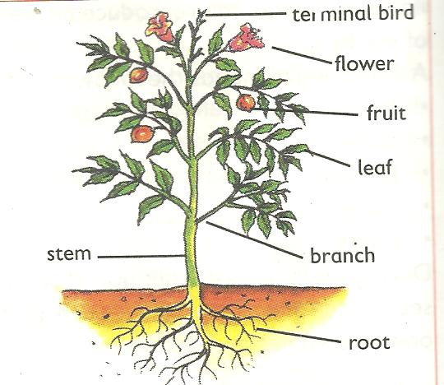

Shoot system

Root system

* Flowering plants have both root system and shoot system
* The root system is the part that grows in the soil
* The root system involves main root, lateral roots, root hairs and the root cap.
* The shoot system is the part that grows above the ground. It consists of: leaves, fruits, stem, buds, branches etc.

**WEEK : 3**

**LESSON 1 : NON-FLOWERING PLANTS**

Non-flowering plants are plants that do not bear flowers.

Non-flowering plants are subdivided into three namely;

* Spore producing.
* Coniferous plants**.**
* Spore producing plants are non-flowering plants that reproduce by means of spores.
* A spore is a single cell that can develop into a new plant under favorable conditions.

Examples of spore producing plants include; liverworts, lichens, mosses and ferns.

* Ferns are the most advanced group of spore producing plants with proper leaves, stems and roots.
* Mosses are small green cushion-like and grow commonly on house roof, verandas, tree trunks, and in damp soils.
* Liverworts have leaf like structures and commonly grow in wet moist places.

**Illustrations showing different examples of spore producing plants.**

|  |  |  |
| --- | --- | --- |
| **01 008Fern plant** | **Moss plant** | **01 008Liverwort plant** |
|  | 01 008 |  |

**Note**:

All spore producing plants have chlorophyll and therefore able to make their own food.

**Coniferous plants** are non-flowering plants that reproduce by means of seeds protected in hard structures called cones.

Conifers have roots, stems and small needle shaped leaves

**Examples of coniferous plants include**

* Pines
* Cedar tree
* Podo tree
* Cypress
* Fir tree
* Ginko

**Economic importance of conifers**

* Some are planted in compounds to provide shade and also act as wind breaks.
* Some conifers are planted around the compounds and farms to act as live fences.
* They are a source of soft wood for making match sticks, soft wood pencils etc

**Learner’s activity.**

1. In one sentence show the meaning of non-flowering plants
2. Mention the two main groups of non flowering plants
3. Conifers cannot bear flowers. How do they reproduce?
4. State two ways in which coniferous plants can be useful to people

**LESSON 5 : PLANT PROPAGATION**

* Propagation is a way plants are grown.

**Types of propagation**

There are two types of propagation:

Seed propagation/sexual propagation

Vegetative propagation/asexual propagation

**Seed propagation** is a way of obtaining new plants by using seeds. The seeds develop into young plants called seedlings. Some seeds are directly planted in the main garden.

Other seeds develop into seedlings that cannot withstand harsh weather conditions such as strong wind, and sunshine.

Such plants are first raised in a nursery bed after which healthy seedlings are transferred to the main garden.

Examples of plants propagated using seeds include: Beans, maize, tomatoes, cow peas, avocado, mangoes etc

**Vegetative propagation**

This is the way of obtaining new plants using other parts of a plant besides the seeds.

It can also be called asexual propagation.

There are two types of vegetative propagation, namely:

* Natural vegetative propagation.
* Artificial vegetative propagation.

Methods of natural vegetative propagation include;

* Spore formation
* Suckers
* Stem tubers
* Leaves
* Bulbs
* Rhizomes and corms.

Methods of artificial vegetative propagation include:

* Stem cuttings
* Budding
* Grafting
* Layering
* Marcotting

**Stem cuttings**

These are short pieces of stems with two or more nodes and axillary buds.

Examples of plants propagated by the use of stem cuttings include;

* Rose
* Hibiscus plants
* Cassava
* Sugarcanes
* Sweet potatoes

**Illustration showing a cassava and sugarcane stem cutting**

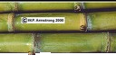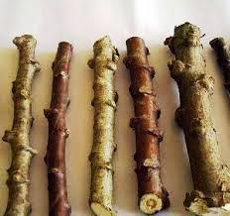

**Bulbs**

A bulb is a short underground stem and swollen fleshy leaves.

Food in a bulb is stored in the fleshy leaves that a swollen.

Bulbs have adventitious roots which develop from the short stem.

* Onions
* Garlic
* Spider lily.

**Illustration showing the bulb of an onion**

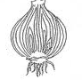

Functions of the parts of the bulb

Foliage leaves

Manufacture food for the plant

Fleshy leaves

Store manufactured food

Stem

Holds the leaves and lateral buds together

Scale leaves

Protect the fleshy leaves (internal parts )

Adventitious roots

Absorb water and mineral salts from the ground

**Suckers**

A sucker is a lateral branch with a terminal bud growing from the base of the underground stem of a certain plant.

Plants propagated using suckers include:

* banana plants
* pineapples
* Sisal plants.

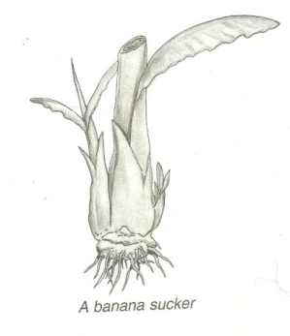**Draw a structure showing a sucker of a banana plant.**

* Plants propagated using stem tubers include;

Irish potatoes

White yam.

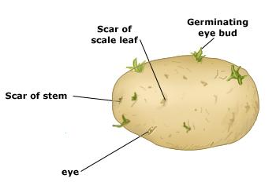**A structure showing parts of stem tuber.**

**Rhizomes**

Rhizomes are swollen horizontal underground stems with stored food.

Examples include, ginger canalily, zoysia grass, couch grass, spear grass and turmeric.

**Illustration of a ginger rhizome**

**Corms**

A corm is a short vertical underground stem swollen with stored food.

It has scale leaves, buds and adventitious roots.

Examples of plants propagated by using corms include:

-Coco yams

-Gladiolus

-Crocus

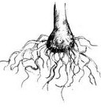**Illustration of a corm**

**BUDDING**

Budding is a method of propagation where a bud of one plant is made to grow on another plant of the same species.

Examples of plants propagated by budding include:

Lemon

Oranges

Avocado

Tangerines

**Illustration showing budding**

**Grafting**

This is a method of propagation where a shoot of one plant is made to grow on another plant of the same species.

Examples of plants propagated by grafting include:

Lemon

Oranges

Avocado

**Illustration showing grafting**

**Marcotting**

This is a method of propagation where a ring is cut through the bark of a healthy branch and then covered with soil in a plastic bag to allow growth of adventitious roots.

**Illustration showing marcotting**

**Layering**

This is a method of propagation where a branch from the mature plant is bent into the soil using pegs until adventitious roots develops from its nodes.

Examples of plants propagated using layering:

* Oranges
* Lemons
* Tangerines

**Illustration of layering**

**Learners’ activity**

1. State what you understand by the term plant propagation
2. Give two methods of plant propagation
3. State how the following plants can be propagated;
4. Sweet potatoes
5. Sisal
6. Give two advantages of vegetative propagation over seed propagation.
7. Name any one crop raised in a nursery bed

**Economic importance of plants**

-natural forests are tourist attractions

-some plants are a source of timber.

-some plants are used as herbal medicine.

-Some plants provide food to animals.

-Plants help in controlling soil erosion.

-plants are wind breaks in gardens and in our compound.

-some plants provide materials for making crafts.

-some plants are grown as a source of income

-plants provide oxygen to animals during photosynthesis.

**LESSON 5 : FRUITS AND SEEDS**

**A fruit** is a developed ovary containing seeds. It has two scars

A **seed** is a fertilized developed ovule. It has one scar.

STRUCTURE OF A FRUIT

**SEED AND FRUIT DISPERSAL**

Dispersal is the scattering of a seed or fruit from the mother plant to other area.

In some plants only seeds are dispersed while other plants it’s the fruits.

**Importance of seed and fruit dispersal**

* Dispersal enables plants to colonize new areas
* Dispersal reduces competition for light and the nutrients among plants.
* Dispersal increases the chance of the plant survival.
* Reduces overcrowdness of plants.

**Agents of seed and fruit dispersal**

There are basically four agents or factors responsible for seed dispersal and these are;-

* Animals, wind, running water and self mechanism or explosive mechanism

**Types or mechanisms of seed dispersal are;**

* Wind dispersal
* Animal dispersal
* Water dispersal
* Explosive mechanism.

**ANIMAL DISPERSAL**

**Characteristics of seeds dispersed by animals**

* They are heavy and have juicy mesocarps
* Some have hook-like structures to enable them attach themselves on the animals’ bodies e.g black jack
* Some have hard seed coats to protect them from the digestive juices e.g guavas
* Many of the fruits have attractive colours when they are ripe e.g mangoes, oranges,

tomatoes etc

* Many of the fruits eaten by animals have sweet and juicy flesh.

**Examples of seeds dispersed by animals are;**

* Mango fruit
* Guava fruit
* Jack fruits
* Avocado fruit etc.

**Illustration showing structure of black jack seed**

**Illustration showing adaptations of a juicy fruit such as pawpaw\orange**

**WIND DISPERSAL**

**Characteristics of seeds dispersed by wind**

* Many are small and light to be easily carried by wind.
* Some have wing-like structures for floating in air e.g jacaranda seeds
* Some have parachute hair structure e.g dandelion seeds, tridax.

**Illustration of wind dispersed seeds**

**SELF DISPERSAL**

Seeds dispersed by ***self mechanisms***split their pods when ripe and disperse their seeds.

These include; castor oil, peas, mahogany, cassava and beans, acacia pods.

**Illustration showing self dispersed seeds**

**WATER DISPERSAL**

Seeds dispersedby***running water*** are of plants that grow on water or near river banks.

Examples include;

Water lilies and coconut fruits.

**Characteristics of seeds dispersed by water**

* They are light which enables them to float on water.
* They have a tight coat which prevents them from germinating and rotting.

**Learner’s activity.**

1. Write one word to mean the scattering of seeds from one mother plant to other areas
2. Write any two methods of seed dispersal
3. Give two ways in which seed dispersal can be useful to plants
4. List two differences between wind and animal dispersed seeds
5. Draw the structure of a tridax

**THEME SCIENCE IN HUMAN ACTIVITIES AND HUMAN OCCUPATION**

**TOPIC : KEEPING CATTLE**

**LESSON6 : IMPORTANCE OF KEEPING CATTLE**

* Keeping cattle refers to the act of rearing bulls, cows, calves, buffalos and heifers.
* Animal husbandry refers to the act of rearing farm animals or livestock.

Terms used in cattle keeping

1. cattle: is a collective name for cow, bull, heifers, calves etc.

2. Bull : is a mature male cattle.

3. Cow: is a mature female cattle.

4. Heifer: is a young female cattle.

5. Bullock: is a young male cattle

6. steer: is castrated bull.

**A drawn structure showing the external features of a cow and a bull.**

Cow Bull

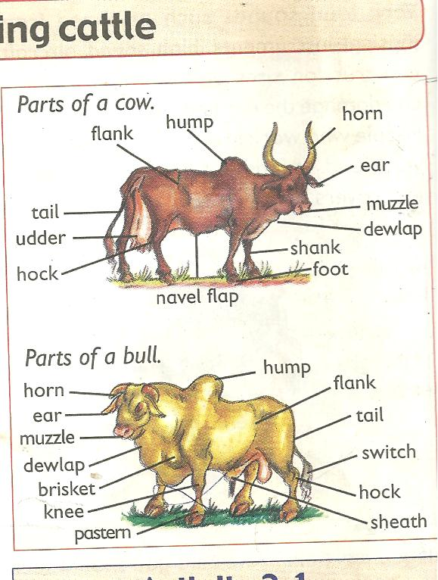

**Reasons why people keep cattle**

* To get beef
* To get milk
* Source of income when sold

**Importance of keeping cattle.**

* Cattle provide people with milk and meat which are sources of proteins.
* Waste materials (dung) from cattle are used as natural manure to improve soil fertility
* Horns are used to make enamel items like plates and cups.
* Hooves are used to make glue
* Hides from cattle are used in making leather products.
* Cow dung can be used in building local houses and making biogas
* Keeping cattle is a source of employment.
* Oxen are used for ploughing and transport
* Used for cultural practices e.g paying dowry

**Learner’s activity.**

1. Write one sentence to show the meaning of the following terms;
2. Keeping cattle
3. Animal husbandry
4. State one reason why many Ugandan have taken up cattle keeping as a business
5. What is the importance of horns and hides to an industrialist

**WEEK : 4**

**LESSON 1 : TYPES OF CATTLE**

A type of cattle is a class of cattle kept for a specific purpose. Specific purpose may be;

* For milk production
* For meat (beef) production
* For both milk and meat production
* Animals for provision of labour

**types of cattle are:**

There are basically four types of cattle namely;

* Dairy cattle for milk production
* Beef cattle for beef (meat) production
* Dual-purpose cattle for the both milk and meat.
* Work-type cattle/ draught cattle.

**DAIRY CATTLE**

These are cattle kept for milk production.

**Characteristics of dairy cattle.**

* They have a thin body that carries little meat
* They have a wide and well set hind limbs
* They have big udders with four medium teats and produce a lot of milk.
* They have triangular body shape
* Usually docile/humble.

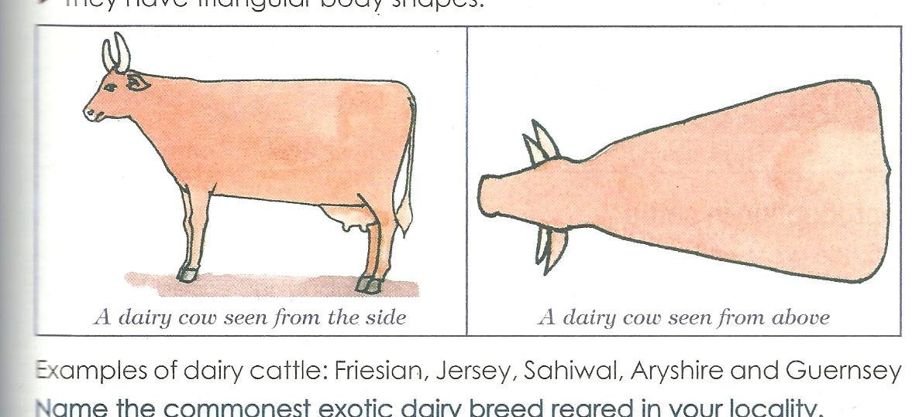**A drawn illustration showing body shape of dairy cattle.**

**Examples of dairy cattle include.**

Friesian, ayrshire, Guernsey, jersey, Jamaican hope and brown swiss cattle.

**Lesson 2 : BEEF CATTLE**

**Beef cattle** are cattle kept for meat (beef) production.

Examples of cattle kept for meat production include;

* Aberdeen angus (weighs 720-900kgs)
* Here ford (weigh about 1000kgs)
* Charolais (creamy in colour)
* Short horn,
* Galloway (it’s small and long haired black)
* American beef master
* Boran

**Characteristics of beef cattle;**

* They have abroad rectangular body shape
* They mature quickly and give plenty or high quantity of meat
* They are very stubborn with no horns
* They have thick muscles.

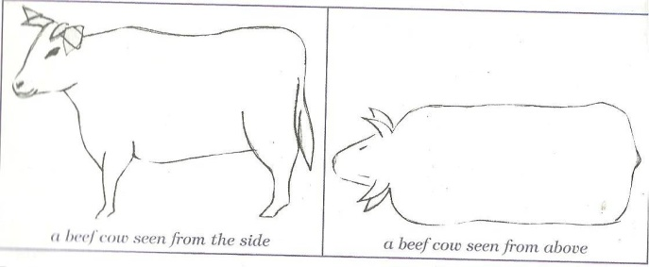**An illustration showing the body shape of beef cattle.**

**Dual purpose cattle**

* These are groups of cattle kept for both milk and meat production

Examples include

* Sahiwal (its brown –red in colour and large in size)
* Red poll (has a medium size with no horns)
* Milking short horn (don’t grow very fast like others but produce hard meat)

**Learner’s activity**

1. What do you understand by the term type of cattle?
2. List any two types of cattle
3. Identify the type of cattle with a rectangular body shape
4. Give two examples of dairy breeds of cattle
5. Name the commonest exotic dairy breed of cattle reared in your locality

**LESSON 3: BREEDS OF CATTLE**

**A breed of cattle** is a family of cattle having specific characteristics.

**Specific characteristics may include;**

* Colour of cattle
* Size of the animals
* Productivity of the animals.
* origin

**Breeds of cattle include;**

* Local breeds of cattle (indigenous)
* Exotic breeds of cattle
* Cross breeds

**Local breeds or indigenous cattle** are breeds of cattle that have lived in East Africa for a long time. They are also called the native breeds kept for both milk and meat production.

*Examples include;*

* East African zebu
* Boran cattle.
* Nsagala or sanga cattle
* Ankole cattle

**Characteristics of local breeds of cattle.**

* They are resistant to tropical diseases
* They have the ability to walk long distances
* They produce good naturally flavoured products
* They can survive on poor pasture and tropical weather conditions.

**Disadvantages of local breeds of cattle**

* They produce less meat and milk
* They have a slow growth rate

**Exotic breeds of cattle**

* These are groups of cattle breeds imported into East Africa.
* They are either dairy, beef or dual-purpose cattle

**Characteristics of exotic breeds of cattle.**

* They grow quickly.
* They are not resistant to diseases.
* They need a lot of attention or care.
* They produce high quantities of milk and beef
* Their products are not as sweet as for the local breeds of cattle

**Note:**

**Cross breeds** are obtained after mating a local breed with an exotic breed (hybrid).

This is the best way of improving upon the poor local breeds of cattle.

**Learner’s activity.**

1. Give the difference between a breed of cattle and a type of cattle
2. Mention any two breeds of cattle commonly kept in Uganda
3. Identify a breed of cattle you would prefer to keep in your locality
4. Give a reason for your answer in (3) above
5. Cite out the best way of improving on our local breeds of cattle

***A DOCUMENTARY ABOUT THE TYPES & BREEDS OF CATTLE***

**LESSON 4 : BREEDING IN CATTLE**

**Breeding** is the act of maintaining or improving the desired characteristics in cattle.

Desired characteristic may include;

* Size of the animal.
* Resistance to diseases.
* Animal’s skin colour
* Productivity of the animals

**Types of breeding**

There are basically five types of breeding namely;

* Line breeding
* Inbreeding
* Cross-breeding
* Out breeding
* Upgrading

***Line breeding:*** is the act of mating closely related animals such as cousins.

This type may result into poor production in animals

***Inbreeding***:is the act of mating closely related animals such as a brother and a sister

This method if not properly practiced, it may also produce poor quality animals.

***Out breeding:*** is the practice of mating distantly related animals such as animals from different herds.

This method helps to restore the qualities in cattle that may be disappearing from a flock.

***Cross breeding:*** is the practice of mating a local breed with an exotic breed of cattle.

After cross breeding, a cross-breed is obtained or a hybrid.

Cross-breeding helps to improve animals with poor qualities

***Upgrading*:** this is the act of improving upon the qualities of one breed.

This is done by mating breeds of superior qualities several times to obtain good breeds in the herd.

**Learner’s activity**

1. In one sentence show the meaning of breeding as used in cattle keeping
2. List down two types of breeding in cattle
3. State why inbreeding is discouraged in the management of cattle breeding
4. How can a local farmer improve on his local breeds of cattle
5. Briefly describe how a hybrid is obtained

**A DOCUMENTARY ABOUT BREEDING IN CATTLE**

**LESSON 5 : REPRODUCTION IN CATTLE**

* Reproduction is the ability to increase in the number of a species of living things
* Cows undergo sexual reproduction which involves production of gametes and then mating.
* A gamete is a reproductive cell. In animals the male gametes are called sperms. While the female gametes are called ova (plural) and an ovum (singular)

**LESSON 6: HEAT PERIOD**

**Heat Period**

This is the time when a cow is in need of a bull for mating.

Mating takes place only when a cow is on heat.

**Signs of a cow on heat**

* It becomes restless
* It mounts other cattle
* It stands while others are lying down
* It urinates frequently
* It puts its tail on the side to enable its vulva to be seen
* There is a mucus discharge from the vulva
* Its vulva swells and changes its colour
* There is a drop in its milk production
* The cow makes a lot of noise (Bellows frequently)

**INSEMINATION (SERVICE)**

*Insemination or* service is the act of depositing sperms into the female reproductive organ of the cow.

For insemination to take place, the cow or a heifer should be on heat i.e. after showing signs

**Types of insemination**

* Natural insemination
* Artificial insemination

*Natural insemination* involves the use of a bull to mount the cow on heat in order to deposit the sperms into the vulva.

**Advantages include;**

* Natural insemination saves time
* It does not need a trained inseminator in order to carry it out.

**Disadvantages**

* More sperms are wasted on one cow.
* It’s very expensive to buy and maintain a bull
* Stronger bull can cause injury to weak cows
* Once the bull dies, sperms are also lost.

**Artificial insemination**

Is the act of introducing sperms in the vagina of a cow by using a catheter or insemination gun.

Semen used is got from healthy bulls with desired characteristics.

**Advantages**

* It reduces the cost of keeping many bulls on the farm.
* It’s cheaper to buy semen than buying and maintaining a bull.
* It prevents injury to small cows and heifers by bigger or heavy bulls.
* It helps to control inbreeding and unwanted pregnancies in cattle
* It promotes selective breeding.

**Disadvantages;**

* It’s difficult and expensive to maintain proper storage of sperms.
* It can’t be applied to animals whose signs of heat can’t be easily identified.
* It requires a trained experienced inseminator
* Animals are denied chance to enjoy sex.

**Learner’s activity**

1. Briefly explain the term insemination
2. Give two ways in which natural insemination can be dangerous to a livestock farmer
3. How does artificial insemination control unwanted pregnancies on a farm.

Identify three signs of a cow on heat

**Fertilization**

This is the union of a male and female gamete to form a zygote. This takes place in the oviduct or fallopian tube.

**GESTATION**

Gestation is the period of pregnancy. It lasts 9 months.

A cow which has shown up signs of pregnancy is called an in-calf cow*.*

Signs of pregnancy

* The udder increases in size and filled up with milk.
* There is mucus discharge around the cervix
* The uterus enlarges in size between 2-3 months

**Learner’s activity.**

1. Briefly explain the following terms
2. Steaming up
3. Drying off
4. Calving
5. How is colostrum important to a calf.
6. Why do you think a cow should be separated from the herd before calving?
7. List down any two signs of a cow on heat

**LESSON 1 : STEAMING UP**

*Steaming up* is the act of feeding an in calf-cow on feeds rich in proteins.

**Advantages of steaming up.**

* It enables the foetus to grow well
* It helps to increase the period of lactation.
* It also prepares the cow for calving.

**CALVING**

Calving is the act of producing calves by a cow.

**Signs of calving in cows**

* Discharge of a fluid from the vulva
* Restlessness
* Loss of appetite
* Labour pains
* Isolation

**LACTATION**

*Lactation period* is a period when a cow produces milk after giving birth.

**Colostrum**

Colostrum is the first milk produced by a cow after calving.

**Importance of colostrums**

* Open the digestive tract of a calf
* Provide a calf with a balanced diet
* Boosts the immunity of a cow

**WEEK : 5**

**LESSON 3: OTHER PRACTICES CARRIED OUT ON CATTLE FARMS**

**Castration**

Castration is the removal of the essential male sex organs called testes. The main aim of castration is to make the bull unable to fertilize a cow.

**Methods of castration**

* Open castration method.
* Closed castration method
* Use of the loop or elastrator method.

In a *closed castration method*, an instrument called a burdizzo is used to crush the tubes leading to the scrotum.

We can also use a rubber ring to seal the sperm ducts and thus destroying the epididymis

**A drawn structure showing a burdizzo**

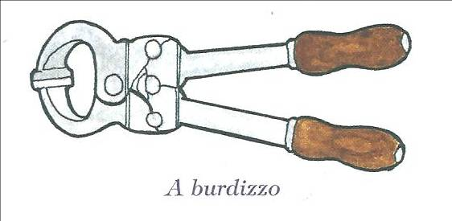

**Note:**

When the jaws of the burdizzo are closed, the spermatic cords are crushed destroying the spermatic nerves.

**Advantages of castration:**

* Castrated bulls grow faster and fatten
* Castrated bulls are calm, humble and easy to handle
* Castration helps to prevent inbreeding (unwanted pregnancies in the herds)
* Castration also helps to prevent diseases on a farm

**Disadvantages of castration**

* Animals are denied chance to enjoy sex.
* There is loss of blood from the animal leading to anaemia.
* The wounds may become septic and the animal may die if not treated well.
* The animal feels pain

**Note:**

*The use of the ring* prevents blood from flowing into the testis that will cause them to shrivel and fall off.

*In an open castration*, the scrotum is cut open using a razorblade or a sharp knife and the testes are removed.

**Learner’s activity.**

1. Briefly explain the term castration
2. Give two reasons why livestock farmers castrate farm animals
3. Cite out any two methods of castrating animals
4. Why do you think bulls which are not castrated usually get STDs?

**LESSON 2 : DEWORMING.**

*Deworming* is the act of giving drugs to animals to kill internal worms.

**Deworming is done in two ways:**

* *Drenching* is the act of giving liquid medicine to animals through the mouth. It can be done by using a drenching gun.
* *Dozing*. Is the act of giving solid medicine to animals in order to kill internal worms.

**Importance of deworming**

* Deworming kills internal parasites like tape worms etc.

**DEHORNING**

is the removal of horn buds from the calf to prevent growth of horns.

Dehorning should be done when the calf is about 2-3 months.

**Methods of dehorning**

* By use of chemical (done between 3-14 days)
* By use of a hot iron (between 7-30 days)
* Use of spoon dehorners. (between 1-2 month)

**Advantages of dehorning**

* It makes the animal easy to handle
* It increases the space in kraals, milking shades and in vehicles during transportation.
* Many animals can be kept in a small space
* It reduces the risk of injury among cows.

**Learner’s activity**

1. Give a difference between drenching and dozing
2. State a reason why livestock farmers should deworm their animals
3. State the importance of dehorning from animals

**LESSON 4 : MILKING IN CATTLE**

**Milking.** Is the method of obtaining milk from the cow’s udder.

* Milk is got by squeezing the teats of cow
* Milk is secreted from the mammary glands of a female animal.
* Milk contains over 85% water and 15% proteins fats, calcium, phosphorous

**Types of milking**

* Hand milking
* Machine milking

*Hand milking*: is the act of squeezing the teats of a cow using hands.

This method can be used to 1-3 animals.

*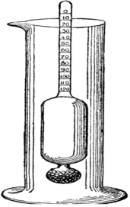Machine milking* is the act of using a machine to squeeze the teats of cow.

Machine milking is the best for more than five animals.

**Note**:

A cow can hold up or milk if it’s disturbed.

**Disadvantages of machine milking**

* Needs a trained person to operate machine.
* The machines are expensive to buy.
* The udder may be injured in case of a machine fault.

**Ways of obtaining clean milk.**

* Prepare the milking place clean and free from dust.
* Wash all the milking containers clean.
* Wash the teats of the cow with warm water to stimulate milk let down.
* Tie the hind legs of the cow and give the cow some feeds to keep busy and relaxed.
* After milking, filter the milk and use a strip cup to detect mastitis in milk.
* Put the milk in clean containers and cover.

**Note**:

*A lactometer* is used to detect the presence of water in milk and separates fats from milk.

**Structure of a lactometer.**

**A drawn structure showing a strip cup.**

* Before actual milking is done, the person milking should smear milk jelly or cream to the teats to prevent them from cracking.
* A cow having mastitis should be milked last and its milk should be poured as treatment goes on.

**Learner’s activity**

1. Identify the type of milking commonly used in your locality
2. State how the following equipments are useful to a live stock farmer
3. A Strip cup
4. A lactometer
5. List down three ways of obtaining clean milk

**LESSON 5: PRESERVATION OF MILK AND MILK PRODUCTS**

**Milk products**

The following are the products got from well processed milk.

|  |  |  |
| --- | --- | --- |
| **Milk products** | **How it’s made** | **Usage** |
| Cheese | Made from fresh milk, skimmed milk or cream. It is made sour by fermenting and then processed, salted and flavoured. | -it is eaten with bread or meat.  -it is a source of calcium and phosphorous  -it is a source of fats and proteins |
| Fresh milk | Boiling and refrigerating | Drunk and added to dishes |
| Skimmed milk | Separating fats from milk | For frying foods |
| Yoghurt | fermenting milk after removing fats | Used to be mixed into rice and other foods |
| Ghee | Made by churning milk | For frying foods |
| Ice cream | Made by mixing liquid milk, cream, powdered milk, sugar, flavor and food colour. The mixture is then frozen |  |

Whey

This is the liquid part left after sour milk has formed curd

It can be used as sauce to accompany food

Casein

This is the part that remains after butter has been removed from the milk.

Casein can be used as a raw material for making shiny paper

**Preservation of milk**

* Milk should be protected from contamination by bacteria for future use.

This can be done by;

* Pasteurization
* Sterilization
* Refrigeration
* Boiling and quick covering

*Sterilization* involves killing bacteria in milk with maximum boiling followed by covering it on cooling.

*Pasteurization* involves strong heating and sealing milk before germs enter.

This method was discovered by Louis Pasteur.

**Note:**

* Boiling is not preferable method because some milk is lost during evaporation.

**Reasons why farmers should keep milk records.**

* To know the amount of milk produced per a cow at a certain period of time.
* It enables a farmer to select animals with less productivity rate for treatment.

**Learner’s activity**

1. State what you understand by the term milk preservation.
2. Give two ways of preserving milk.
3. State how yoghurt is made from milk .
4. State the importance of the following milk products to people
5. Cream
6. Ghee
7. Butter
8. Give two reasons for preserving milk.

**LESSON 6 : CATTLE PARASITES**

*A parasite* is an organism that depends on another organism for food and shelter without killing it.

Cattle parasites are divided into two;

* External parasites (ecto-parasites)
* Internal parasites (endo-parasites)

**External parasites (ecto parasites)**

Theseare parasites that live outside the body of the animal. They suck blood from the animal.

**Examples include:**

Ticks, lice, mites, tsetse flies, fleas etc.

*Ticks* suck blood from the animals and spread tick borne diseases such as;

* East coast fever
* Red water
* Heart water.
* Anaplasmosis

*Tsetse flies* spread germs that cause Nagana or trypanosomiasis to cattle.

**Internal (endo) parasites**

These are parasites that live inside the body of the animals and mainly in the intestines.

They suck blood and feed on the digested animal’s food.

They are mainly worms.

**Examples include;**

* Hook worms feed on blood
* Tape worms feed on digested food
* Liver flukes live in the bile duct or liver.

**Ways of controlling cattle parasites**

* Spraying the animals using acaricides
* Practicing rotational grazing to avoid tick borne diseases
* Dipping cattle into chemicals
* De-worming cattle to kill intestinal worms

**Learner’s activity**

1. What do you understand by the term parasites?
2. Name the two types of parasites
3. How do parasites gain entry into the animal’s body?
4. Give two examples of external cattle parasites
5. Briefly explain two ways of controlling parasites on a farm

**WEEK : 6**

**LESSON 1 : CATTLE DISEASES**

Cattle diseases are classified into three groups according to the causative agents i.e.

* Bacterial diseases
* Viral diseases
* Protozoan diseases

**Causes of sickness in cattle**

* Lack of essential nutrients in their feeds
* Unhygienic conditions like dirty feeding troughs.
* Overcrowding of animals
* Physical injuries and infections caused by micro-organisms

**Signs of a sick animal include;**

* Animals appears gloomy and restless
* Body temperature may be high or low
* It may pass out urine with strange colours
* Difficulty in breathing or even coughing
* Diarrhea or scouring may occur

|  |  |  |  |
| --- | --- | --- | --- |
| **Name of disease** | **How it’s spread and caused** | **Signs and symptoms** | **Prevention control and treatment** |
| **Bacterial diseases** | | | |
| Anthrax | * Caused by Bacteria * Spreads through body contacts and contaminated feeds | * High fever * Loss of appetite to graze. * Sudden death * Blood stained dung | Bury deeply dead animals  Burn the dead animals  Vaccinate animals every year  Separate infected animals |
| Mastitis | * Caused by bacteria * Spreads through body contact with an infected animal | * Milk with blood stains or pus * Swollen and painful teats and udder. * A cow refuses to be milked and suckled | Early treatment by using antibiotics  Use a strip cup regularly |
| Pneumonia | * Caused by bacteria * Spreads from contaminated air and dirty living pens | * Difficult breathing, coughing, * Nasal discharge * Loss of appetite * High fever | Use well ventilated dry and clean pens.  Treat the animal at the early stage of the disease |
| Tuberculosis | * Breathing in air with tuberculosis bacterial * Spreads through milk of infected cows | * Coughing * Loss of weight * Loss of appetite | Kill infected animals  Separate infected animals from health ones  Have proper sanitation  Early treatment using antibiotics |
| **Viral diseases** | | | |
| Foot and mouth disease | * Spreads through sharing feeding containers * Through body contacts with infected animals | * Swollen teats and lameness * Blisters on top of hooves and mouth (muzzle) * Loss of appetite to graze * High temperature * Reduction in milk production | Separate sick animals  Vaccinate after every 6months  Application of a quarantine. Quarantine is the restricted movement of animals and their products from one place to another due to disease outbreak |
| Rinderpest | * Spread through body contact with an infected animal | * Soars in the mouth * Sunken eyes * Nasal discharge * Tears from eyes * High temperature * Diarrhea with blood stains | Separate sick animals  Regular vaccination  Slaughter the infected ones |
| * **Protozoan disease** | | | |
| Nagana (trypanosomiasis) | * Spreads through the bites of infected tsetse flies | * Loss of weight * Anemia * Loss of appetite * High fever | Spread the tsetse flies using insecticides |
| East coast fever | * Through bites of infected ticks   (brown ear tick) | * Nasal discharge * Diarrhea * Loss of appetite * High temperature * Weakness | Dipping and spraying animals with acaricides to control ticks |
| Heart water | * Through bites of infected ticks   (brown ear tick) | * Animals walk in circles. * Animals place their heads on objects * When the animal falls, legs keep paddling in air | Dipping and spraying animals with acaricides to control ticks  Treat early cases with tetracycline antibiotics and sulphadilimidine |
| Red water | Spread through tick bites (red ticks Spreads through tick bites (red tick) | * High fever * Reddish urine due to damaged liver. * Animal licks soil | Vaccinate regularly.  Dip and spray with the acaricides to kill ticks. |

**Learner’s activity**

1. Give a difference between viral and bacterial diseases
2. Point out any one cause of sickness in cattle
3. Identify the infection of cattle that attacks
4. Udder and teats
5. Respiratory system of the animal
6. Give two ways of controlling cattle diseases

**LESSON 2 :**

**PRACTICES THAT HARM CATTLE IN THE FIELD,TRANSIT AND IN THE ABATTOIR:**

1. **In the field:**

* Beating them
* Overcrowding them
* Exposing them to harsh environmental conditions e.g too much rain, sunshine.
* Inappropriate feeding
* Fighting amongst themselves

1. **In transit:**

* Overcrowding them on trucks
* Starving them
* Inappropriate loading and offloading them
* Transporting them for long hours without rest

1. **In the abattoir**

* Starving them
* Putting them in dirty places
* Beating them

**IMPORTANCES OF PROPER HANDLING OF FARM ANIMALS**

i)it improves the quality of meat

ii)it improves the quality of the skins

**LESSON 3 :**

**GRAZING /FEEDING IN CATTLE**

**Methods of grazing**

There are three main methods of grazing cattle namely;

* Rotational grazing
* Zero grazing
* Herding or free range system

**Rotational grazing**

This is the type of grazing in which animals graze on one portion of pasture at a time. This can be done using the following systems;

* Paddocking
* Strip grazing
* Tethering

**Paddocking**

This is when a farmer feeds his animals on a big pasture land divided into paddocks.

Cattle are fed on grass in a paddock and when the grass is no longer enough they are moved to another paddock.

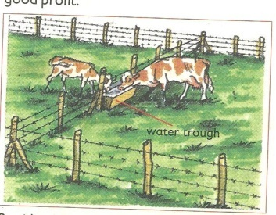**An illustration of paddock grazing**

**Advantages of paddock grazing**

* Paddocks help to avoid overgrazing
* Paddocking controls pests and diseases
* Paddocking enables the animals to have grass all the time.
* It lessens the labour used to look after the animals after setting up paddocks.
* Paddocks help to control the spread of diseases
* The dung and urine of the animals are evenly distributed.

This allows for new grass to grow well in all paddocks.

**Disadvantages of Paddocking**

* The materials needed are expensive
* Animals have no choice of the type of plants to eat
* It requires a big portion of land
* The barbed wires can tear the skin of the animals

**Strip grazing**

This is where small sections called strips are created using temporary electric wires to restrict movements of animals.

Animals graze in gazetted area.

**Advantages**

* Pasture is evenly used
* Diseases and vectors are controlled
* Labour is reduced on the farm

**Disadvantages**

* It’s expensive to start and maintain
* It requires few animals to be kept

**Tethering**

This involves tying the animal on a tree or a peg using a rope to graze in a limited area

This is the most common method used in East Africa .

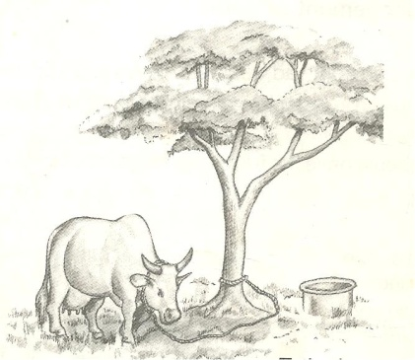**A structure showing tethering method**

**Advantages of tethering method.**

* It’s cheap and appropriate to maintain
* No fencing is required
* Pasture chosen by the farmer is always the best

**Disadvantages**

* It can only work best for few animals
* Animal feeding is only limited to areas around the peg.
* It requires the farmer to keep transferring the animals when pasture is over.

**Learner’s activity**

1. One sentence, show the meaning of the phrase rotational grazing
2. Give two advantages of rotational grazing
3. Identify any two methods of rotational grazing
4. Briefly explain how strip grazing can be a disadvantage to a livestock farmer
5. Give two advantages of paddock grazing to a farmer

**LESSON 3 : HERDING**

**Herding (free range grazing)**

This is a system where animals are left free to graze on different types of pasture as monitored by a herdsman.

This system is mainly practiced by Normadic pastoralists

**Advantages**

* Animals are able to do some exercises as they graze
* It does not require any fencing
* The animals graze on different pastures of their choice

**Disadvantages**

* Animals need a herdsman to look after them all the time
* Animals can easily stray and destroy farmer’s crops
* Inbreeding is difficult to control

**ZERO GRAZING**

**Zero grazing**

This is a system where animals are kept under a special structure and water or feeds are provided.

Small cubicles are made for animals to rest and feed.

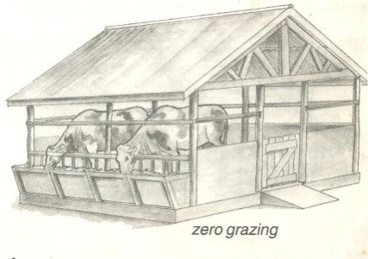**An illustration of a zero grazing unit**

**Advantages of zero grazing**

* It’s easy to collect manure (Farm Yard Manure)
* Animals are easy to control and monitor
* Feeds are not wasted since animals are given only what is enough.
* Animals are protected from bad weather like sunshine and heavy rains

**Disadvantages of zero-grazing**

* It’s very expensive to start and maintain
* The farmer gets over worked
* There is easy spread of diseases and pests
* It involves of either buying feeds or growing fodder crops
* Much labour is required to feed and monitor the animals

**Learner’s activity**

1. Explain the following terms;
2. Herding
3. Zero grazing
4. Outline any three advantages of herding
5. How can zero grazing be a disadvantage to a farmer?

**LESSON 4 : HOUSING OF CATTLE**

Like any other animals, cattle need good housing. They should be provided with shelter for the following reasons;

* To protect them from bad weather like heavy rain and strong sunshine.
* To protect cattle from thieves
* To protect cattle from attacks by wild animals
* To maintain their health and ease their feeding

**Qualities or characteristics of a good house of cattle**

The house for cattle is called a byre / kraal.

It has the following characteristics;

* Well ventilated for free air circulation.
* Has a strong floor made of concrete for easy cleaning.
* Has a slanting to enable urine drain out.

**Materials used to build cattle houses include**

Wood, concrete, metals, bricks, plastics, stones etc

**FENCING**

A fence is a barrier of life or dead materials divided in areas of land

There are two types of fences namely;

* Planted fences
* Constructed fences

Planted (natural) fences are made by planting certain types of plants along margins of a given piece of land.

Constructed (artificial) fences, are fences were people-made materials are used to create a barrier along a particular piece of land.

The materials used when constructing artificial fences include;

* Treated poles
* Bubbled wires
* Bricks
* Wire nets
* Chain links, etc

This type of fence is the most popular one.

**Importance of fencing**

* Natural fences are wind breaks thus controlling soil erosion
* Natural fences can maintain soil fertility by adding humus to soil
* Fencing controls the spread of pests and diseases to animals
* It also prevents animals from destroying people’s crops
* It allows proper use of pasture.
* makes culling easy

**Learner’s activity**

1. Give two reasons for housing cattle
2. What name is given to the house for cattle
3. List any two qualities of a good house for cattle
4. What do you understand by the term “fence”?
5. Identify any two reasons for fencing farm animals

**LESSON 5: STARTING A LIVESTOCK FARM**

*Livestock* refers to the animals kept on a farm. These may include;

* Poultry
* Goats
* Sheep
* Pigs and
* Cattle

Livestock farming is the rearing of farm animals.

**It’s important to people in the following ways;**

* It’s a source of income when animals and their products are sold
* It’s a source of food
* It provides employment opportunities to people

Requirements for starting a livestock farm.

***Land:*** this is a place on which the farm is started. It may be obtained in the following ways;

* By buying
* Through inheritance
* From donation

*Capital,* this is the money used to buy things needed to start a farm. Some of the things the money may be used for include;

* Buying land if it is to be bought
* Constructing animal houses, stores, office and stationery.
* Preparation of pasture
* Bringing water on the farm
* Paying workers and experts for the treatment an vaccination of the farm animals before the farm starts producing.
* Buying drugs, acaricides and necessary equipments for the farm.

*Labour,* this includes people who do activities on a farm both skilled and unskilled workers.

*Market,* in live stock farming, marketing refers to the demand for cattle or their products.

Demand for cattle products means the desire and ability to pay for the products.

Therefore, it’s important to know whether people are ready to buy the products from the farm.

*The type of livestock,* the farmer needs to identify which animals he or she wishes to keep.

**Learner’s activity**

1. Give a difference between livestock and livestock farming
2. Today in Uganda, many people prefer livestock farming to crop growing. Give two reasons for this.
3. Identify any two ways of obtaining land for starting a livestock farm.
4. List any two activities done by skilled and non-skilled worker on a farm.
5. Give two ways in which capital can be used in starting a livestock farm

**THEME : THE ENVIRONMENT**

**TOPIC : RESOURCES IN THE ENVIRONMENT**

**LESSON 4 : DESCRIPTION OF RESOURCES**

**Resources**

* A resource is anything that can satisfy people’s needs.

**Types of resources**

* **Renewable resources** / inexhaustible resources
* **Non- renewable** **resources** / exhaustible resources

***Renewable resources*** are resources that can be replaced naturally when used up.

**Renewable resources include;**

* Water
* Plant
* Animals
* Air
* Soil
* Sunshine

**Importance of plants as resources.**

* Some plants are eaten as food.
* Plants provide wood fuel to people when dried
* Some plants are used as herbal medicine to cure animal diseases.
* Plants provide raw materials for furniture and crafts
* Plants help in the rain cycle through transpiration.

***Non-renewable resources.***These are resources that cannot be replaced naturally when used up.

These resources can be exhausted in case they are not properly handled and preserved.

**Examples include;**

* Rocks
* Petroleum
* Minerals
* Sand
* Naturalgas
* Clay Soil

**Ways people use animals as a resource**

* Animals products (meat and milk) are good sources of proteins to people’s diets.
* Animals provide labour such as pulling carts, ploughing and for transport.
* Animal wastes can be used to make biogas.

**Examples of such animals include**;

* Horses,
* Camels,
* oxen.
* Donkeys.

**Learner’s activity**

1. Differentiate between renewable and non renewable resources
2. Give two examples of renewable resources in your environment
3. Write one sentence to explain why copper is regarded as a non renewable resource.
4. Stat one way in which the following can be used as a resource.
5. Water
6. Soil

**LESSON 5: NON LIVING THINGS AS RESOURCES**

Non-living components in the environment are used by people for a certain purpose.

**These include**: air, water, soil, sun and minerals.

* Water is a renewable resource because it can be replaced naturally through the rain cycle.
* Air is also a renewable resource because it can’t get exhausted in the environment.
* Air is a mixture of gases such as, oxygen, carbon dioxide, nitrogen, argon, krypton, neon etc.
* Wind is air in motion caused due to difference in temperature of places.

**Ways air is used as a resource in the environment.**

* Air from the environment is breathed in by people and animals
* Oxygen from the atmosphere helps in the processes of germination, burning and rusting.
* Carbon dioxide gas is also used as a preservative gas for tinned or canned foods.
* Carbon dioxide is used in fire extinguishers.

**Ways water is used as a resource.**

* Fast flowing water helps in turning turbines used in generation of hydro-electric power.
* Water serves as a habitat for aquatic life like fish, amphibian, marine mammals etc)
* Water helps in plant processes such as germination and photosynthesis.
* Water is used as a raw material in industries and for cooling machines.
* Water is used for domestic activities.

**LESSON 6 :** **NON LIVING THINGS AS RESOURCES**

**Minerals in the environment**

* Minerals are resources dug from underground
* Minerals were formed from the remains of animals and plants that lived many years ago after their death and decomposition.
* Minerals are non-renewable resources in the environment

**Examples include;**

Oil, clay, chalk, copper, gold, petroleum, uranium, coal, rocks, tin etc

* Minerals from which metals are made are got from ores which contains more than one metal.
* Coal and oil are used to provide fuel in many ways. Coal can also be burnt to produce thermal electricity.
* Crude oil is taken to refinery to obtain pure oil by a process called fractional distillation.

**Products obtained from petroleum.**

* Petrol
* Diesel
* Engine Oil
* Kerosene

-Jet fuel

A **rock** is made up of many minerals tightly packed to form a solid.

**Fossils** are remains of plants and animals that had lived many years ago.

Their remains include; bones, teeth, roots, stems or leaves.

Fossils are mainly found in stone quarries

**Uses of rocks**

* Rock contains minerals
* Rocks describe the earth’s history
* Rocks are used as raw materials for construction work

**Learner’s activity**

1. Write any one way in which each of the following can be used as a resource;
2. Water
3. Sun
4. Soil
5. Air
6. How can rocks be useful to people? (Give one way)
7. Briefly explain the term fossils

**WEEK : 8**

**LESSON 1 : ALLOYS**

**Alloys**

An alloy is a mixture of two or more metals

**Examples of alloys include;**

* Brass
* Bronze
* Solder
* Dentist amalgam

**Importance of making alloys**

* Alloys make the metal harder
* Alloys lower the melting points of metals.
* Alloys make the tear or wear of metals difficult

**A table showing an alloy, how it’s made and its use.**

|  |  |  |
| --- | --- | --- |
| **Alloy** | **Combination** | **Importance** |
| Brass | Copper and zinc | Decorating the ornaments  Making wires, tubing cases of bullets |
| Bronze | Copper and tin | Decorating metals  Making coins |
| Solder | Leas and tin | Filling dental cavity in the teeth |
| Manganese steel | Iron and manganese | Making garden gates etc. |

**Note**:

Fuels are materials that can burn to give out heat and light.

Examples of fuels include; charcoal, coal oils, fire wood (petroleum)

**Learner’s activity**

1. Briefly explain the term alloy
2. Give two examples of alloys
3. State then importance of the following alloys;
4. Brass
5. Manganese steel
6. Point out any two uses of alloys in our society

**LESSON 2 : CONSERVATION OF RESOURCES**

*Conservation* is the protection of the resources in the environment from exhaustion.

Conservation involves caring for the resources to avoid the exhaustion for future use.

Man uses resources from the environment to obtain useful energy.

*Plants* from the environment provide fibres such as sisal, jute, cotton and linen.

A **fibre** is any material from plants or animals that is made up of threads and can be used as a resource.

**Examples of plant fibres**

Sisal, cotton wool, banana fibres, raffia, hemp, jute etc

Examples of artificial fibres

Nylon, rayon

**Examples of animal fibres**

Silk, mohair, wool, fur, spider webs etc

* *Animals* provide energy for pulling carts and ploughing e.g oxen
* Animals Also provide transport e.g. donkeys, horses and camels.
* We need to conserve plants, animals, minerals, water, soil, wildlife etc.
* Wildlife refers to animals and plants in the entire environment outside our homes.

**Ways of conserving resources in the environment.**

* Use of modern farming practices such as terracing, inter cropping etc.
* Enforcing laws against bush burning and swamp drainage.
* Gazetting and protecting swamps, national parks and forests.
* Practicing agro-forestry, reafforestation and afforestation.
* Use of other alternatives to wood fuel such as use of solar electricity.
* Discouraging poaching
* Use of 5Rs in waste management i.e Reject, Return, Reuse, Recycle, Reduce.

**Learner’s activity**

1. What do you understand by the term conservation of resources?
2. Give two ways of conserving the following resources in our environment
3. Wild life
4. Soil
5. Minerals
6. Briefly explain the term fibre
7. Give two examples of plant fibres

**THEME : THE HUMAN BODY**

**TOPIC : RESPIRATORY SYSTEM**

**LESSON6 : ORGANS OF THE RESPIRATORY SYSTEM**

**The respiratory system:**

This is a group of organs in which gaseous exchange takes place

**Respiration** is the process by which the body uses food and oxygen to release energy.

**Bi-products of respiration**

Heat, carbon dioxide and water vapour.

Respiration takes place in the body cells.

**Organs/ major parts of the respiratory system.**

* Nose
* Trachea Or Wind Pipe
* Bronchus
* Lungs
* Diaphragm

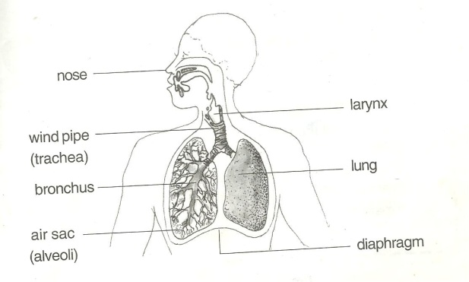**A drawn structure showing the respiratory system.**

**Functions of the parts**

*The nose:*

The nose is used for smelling and breathing

* It contains mucus and tiny hair (cilia) used to filter air
* Cilia traps dust that enters with air
* Mucus helps to moisten and warm air.

As air enters into the nose, it is moistened, warmed and filtered.

*The wind pipe/trachea*

The trachea is a tube. It directs air to and from the lungs.

* It’s made up of soft bones called cartilage to keep it open all the time
* It also contains hair and mucus for trapping dust and germs

*The epiglottis:*

* Closes to prevent the food from entering into the wind pipe on swallowing.

*The lungs:*

* This is the organ where gaseous exchange takes place in the body.
* It has got air sacs (alveoli) with a net work of blood capillaries to absorb oxygen and pass out carbon dioxide.

*Rib cage:*

* Protect the lungs and heart against external harm.
* It’s also covered with a pleural fluid to prevent friction between the thorax and lungs to the ribs.
* Intercostal muscles holds the ribs together.

**Note**:

Gaseous exchange takes place at the air sacs.

**Learner’s activity**

1. State the importance of respiration to the body
2. Give a reason why it’s not advisable to breathe through the mouth
3. How are cilia useful to people during breathing?
4. State the importance of the following organs of the respiratory system;
5. Nose
6. Rib cage
7. Epiglottis

**WEEK : 7**

**LESSON 1: BREATHING**

*Breathing* is the act of taking in and sending out of air.

Breathing involves exchange of gases in an organism

Breathing starts from taking in air through the nose to the lungs.

**Types of breathing:**

There are two types namely;

* Inspiration (inhalation) and
* Expiration (exhalation)

**Breathing in / inspiration / inhalation**.

*Inspiration* is the act of drawing in air into the lungs through the nose.

The air we breathe in contains more oxygen than carbon dioxide.

We breathe in to increase oxygen supply in the body

Oxygen is used by the body to burn food and produce energy during respiration

*Respiration* is the oxidation of food to produce energy in the body cells

**Events during inhalation / breathing in.**

* The diaphragm moves downwards. (Diaphragm contracts and flattens)
* Ribs move upwards and out wards.
* Lungs expand
* The chest increases in volume
* Air is drawn into the lungs.

**Expiration / breathing out / exhalation**

This is the act of taking out of air from the Lungs through the nose.

* We breathe out to reduce carbon dioxide in the body.
* Air we breathe out contains more carbon dioxide than oxygen
* During breathing out, we also lose excess heat and vapour from the body.

**Events during expiration / breathing out / exhalation**

* The diaphragm moves upwards to its domed shape.
* The ribs move down wards and inwards
* The lungs reduce in size

**Note**:

* Carbon dioxide dissolved in the blood plasma diffuses from the capillaries into the alveoli and exhaled out.
* Abrupt coughing is caused when an external matter enters the trachea or wind pipe

**Learner’s activity**

1. Differentiate between breathing and respiration
2. State what happens to the following parts during breathing in
3. Diaphragm
4. Lungs
5. Intercostals muscles
6. By what process does carbon dioxide move from capillaries to lungs?

**LESSON 2: ADAPTATION OF THE AIR SACS TO THEIR WORK**

**Gaseous exchange in the alveolus**

Gaseous exchange takes place in the alveoli (air sacs) found in the lungs.

When blood reaches the alveoli, carbon dioxide is lost and oxygen is added to blood.

Oxygen is added to blood and carbon dioxide is lost by a process called diffusion.

**An illustration showing gaseous exchange at the alveoli.**

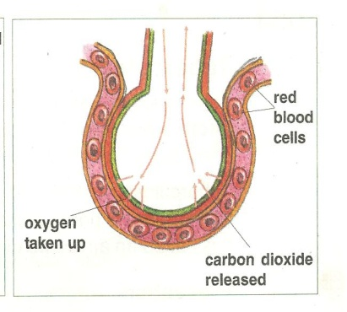

**Note**:

* Alveoli are plural while alveolus is singular.

**How are air sacs suitable for gaseous exchange**

* They are thin walled to allow gaseous diffusion through.
* They are surrounded by a network of blood capillaries.
* They are many in number to provide a large surface area to ease gaseous exchange.

**Summary of the composition of inhaled and exhaled air**

|  |  |  |
| --- | --- | --- |
| **Gas** | **Inhaled air** | **Exhaled air** |
| Oxygen | 21% | 16% |
| Carbon dioxide | 0.03% | 4% |
| Nitrogen | 78% | 78% |
| Water vapour | Less | More |
| Rare gases | 0.97% | 0.97% |

**Note:**

* As we breathe out, more carbon dioxide is expelled because some is added from the body cells.
* Nitrogen is left unchanged because it is not necessary in the body.
* We breathe out less oxygen because most of it is used by the body during respiration process.

**Learner’s activity.**

1. State two ways in which air sacs are adapted for exchange of gases.
2. Study the table below and answer the questions that follows;

|  |  |  |
| --- | --- | --- |
| Component | Inhaled air | Exhaled air |
| Oxygen | 21% | 16% |
| Nitrogen | 78% | 78% |
| Carbon dioxide | 0.03% | 4% |

Briefly explain why;

1. Exhaled air contains little oxygen
2. Concentration of nitrogen remained unchanged
3. Exhaled air contains more carbon dioxide

3.Why does the mirror become cloudy you breathe out closely to it?

**LESSON 3 : DISEASES OF THE RESPIRATORY SYSTEM.**

*Respiratory* diseases are diseases that affect people’s respiratory organs i.e. the lungs, trachea, nostrils, and bronchioles.

* Some respiratory diseases are communicable diseases spread through contaminated air while others are non-communicable caused by smoking.
* Some respiratory diseases are hereditary spread from parents to the babies.

***Diseases of the respiratory system.***

|  |  |  |
| --- | --- | --- |
| **Diseases** | **Signs and symptoms** | **Prevention / control** |
| Lung cancer (caused by smoking) | * Chest pain * High fever * Coughing | * Avoid smoking tobacco * Seek medical treatment |
| Influenza (flu)  (caused by virus) | * Difficulty in breathing * Constant coughing and sneezing | * Drink a lot of fluids |
| Pneumonia caused by either bacteria or virus | * Difficulty in breathing * Coughing * Fever | * Wear warm clothes during cold weather. * Treat using antibiotics. |
| Bronchitis (caused by bacteria) | * Difficulty in breathing * Chronic coughing | * Avoid smoking |
| Tuberculosis. (caused by bacteria) | * Coughing for a longtime * Thick mucus spitting with spotted blood * Chest pain | * Isolate the infected ones * Immunise using children BCG * Vaccine * Avoid drinking unboiled milk. |
| Whooping cough  (caused by bacteria) | * Blocked nose * Coughing spasm * Difficulty in breathing * Running nose * Whooping sound when coughing | * Drink fluids rich in vitamins * Immunise children with DPT vaccine. * Avoid overcrowded and poorly ventilated houses/places. |
| Asthma (allergies) | * Difficulty in breathing * Body weakness during cold weather. * Mucus flow | * Go for medical attention * Keep away from sources of allergies e.g. cold pollen grains. |
| Diphtheria (caused by bacteria) | * Sore throat * Swollen neck | * Immunise the infants using DPT vaccine * Go for medical treatment in time. |

**Learner’s activity.**

1. Identify any two diseases of the respiratory tract
2. Describe any two ways of keeping the respiratory system in a healthy working condition.
3. Draw the structure of the respirator system and name the parts;
4. Trachea
5. Left bronchus
6. Diaphragm
7. Lung

**WATCHING DOWN LOADED INFORMATION ON HOW LUNGS/ ALVEOLI WORK (PRACTICAL)**

**Disorders of the respiratory system**

**-**Choking

-Suffocation

-Inflammation of the tissue within the nose and the lungs

-Nasal congestion

**How to keep the respiratory system in a healthy working condition**

Having a balanced diet

Having regular physical exercise

Going for regular medical check up

Avoid breathing through the mouth

Early treatment of respiratory diseases

Avoid living in places with a lot of smoke and dust.

Drinking plenty of water

**Avoid smoking cigarettes**

**Immunization of diseases such as diphtheria, tuberculosis etc.**